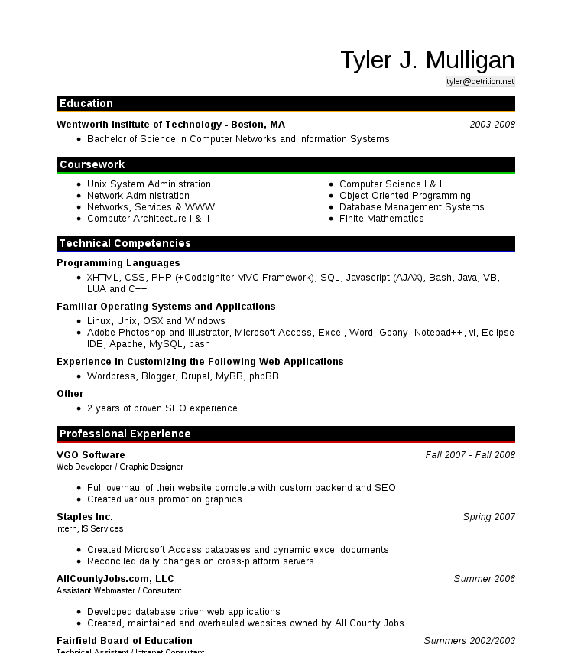

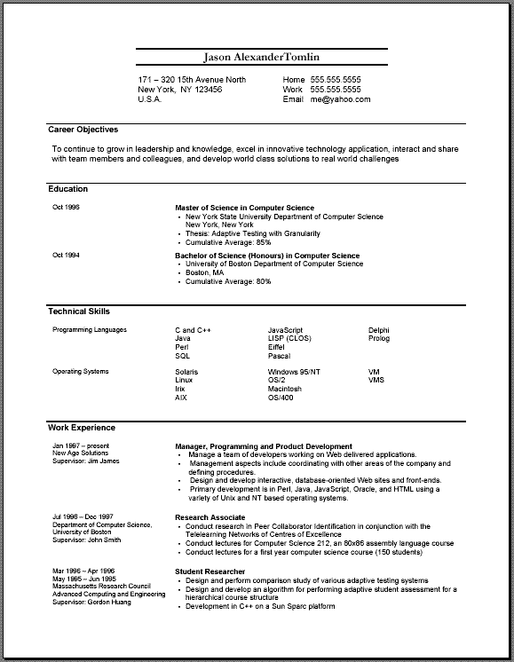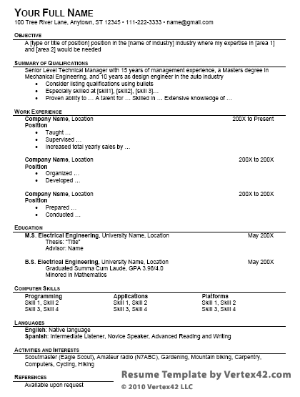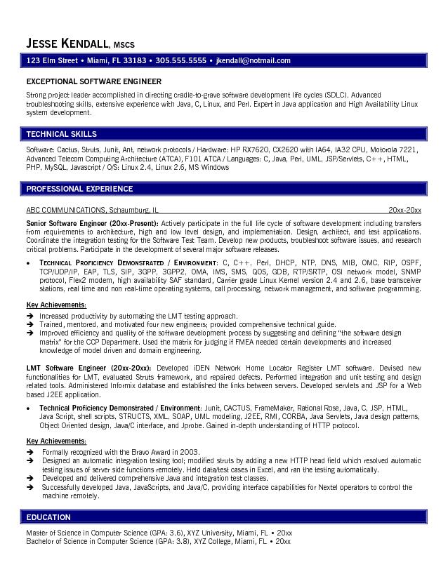

[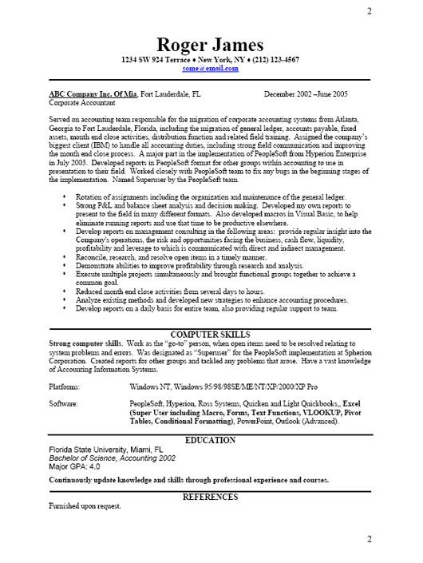](http://www.google.com/url?sa=i&rct=j&q=&esrc=s&frm=1&source=images&cd=&cad=rja&docid=oBNilbhY0PGrLM&tbnid=0f5CRKFY3UPuoM:&ved=0CAUQjRw&url=http://www.resume-business.com/business-resume-sample.php&ei=Q-wUUoyvIK_K4AO2-oHgDQ&bvm=bv.50952593,d.aWc&psig=AFQjCNELqjXG3xmX9ukMHEwGP1zJNVWWCQ&ust=1377188955461759)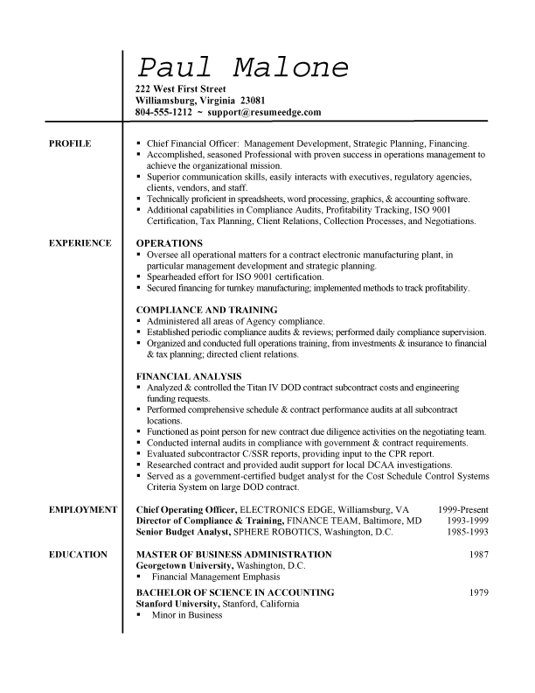[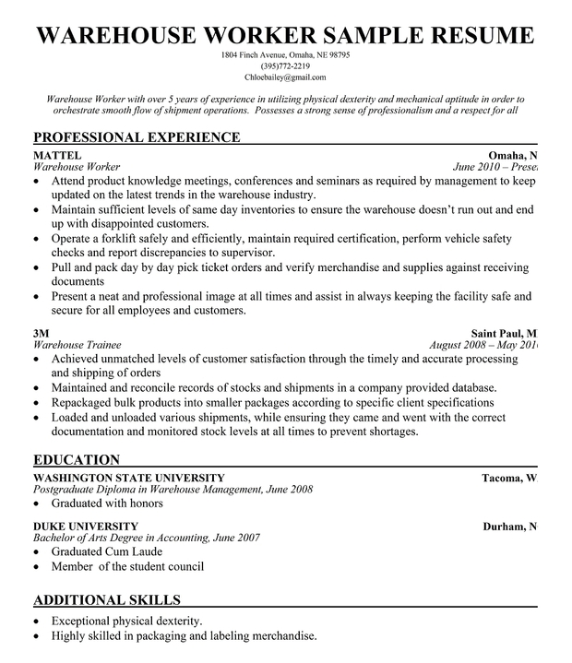](http://www.google.com/url?sa=i&rct=j&q=&esrc=s&frm=1&source=images&cd=&cad=rja&docid=SOsXbXq3C1EvYM&tbnid=lOs_g9V8NIpLnM:&ved=0CAUQjRw&url=http://resumecompanion.com/resume/warehouse-worker-resume-sample&ei=Qe0UUvyPOO7J4APk0YGYCQ&bvm=bv.50952593,d.aWc&psig=AFQjCNELqjXG3xmX9ukMHEwGP1zJNVWWCQ&ust=1377188955461759)